First , docker was installed and oracle xe image container was downloaded from docker hub.

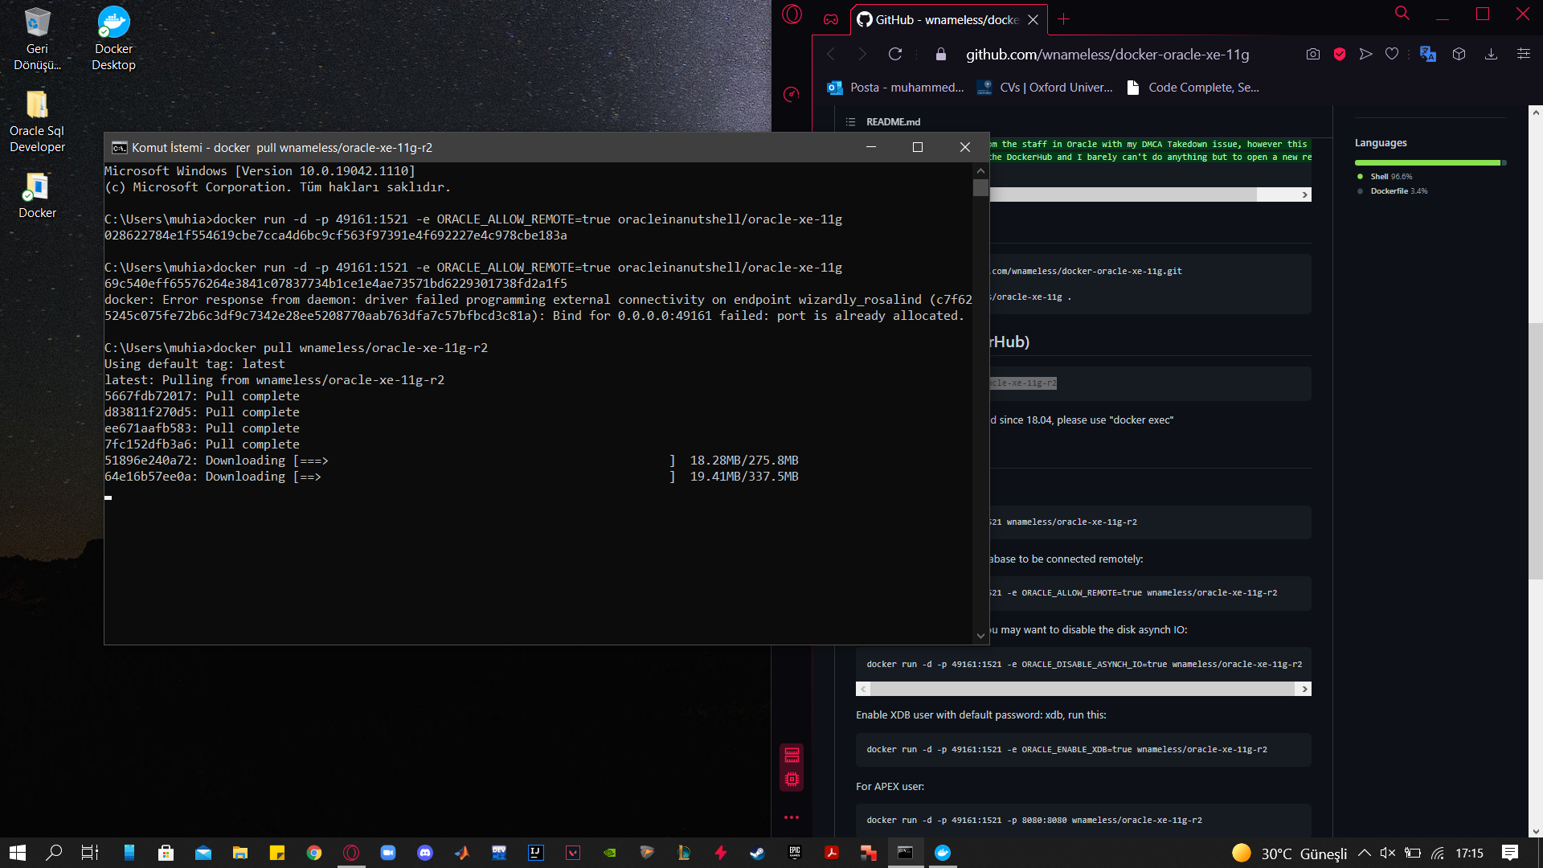

metin, ekran görüntüsü, ekran, siyah içeren bir resim

Açıklama otomatik olarak oluşturuldu

In the next step, contacted oracle sql developer .

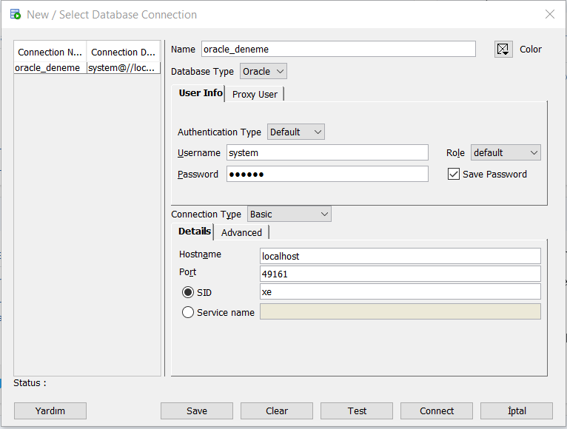

Test table were tested with the established connection.

tablo içeren bir resim

Açıklama otomatik olarak oluşturuldu

KEY WORDS

Containeriztion: Containeriztion is the packaging of software code with only the operating system libaries and dependencies needed to run the code to creta a single container that Works consistenly on any infrastructure.

Virtualization: Virtualization is a techonlogy that allows you to create useful services using resources traditionally tied to hardware. It allows you to use the full capacity of a physical machine by distributing its capabilities among many user sor envitoments.